Visualizing and Predicting Heart Diseases with an Interactive Dash Board

Team ID: PNT2022TMID10044

Faculty Mentor: Team Leader : Sakthivel M

T K P Rajagopal Team Member : Sadhana M

Team Member : Sirisha G

Team Member : Sneha Bharathi V

Average Exercise Angina During Chest Pain

What Causes Angina?

The heart is a muscle that must receive oxygen all the time. Angina means that the heart muscle starts to hurt from not receiving all of the oxygen that it needs. The most common type of angina is called stable angina. Stable angina means that you develop chest pain when you exercise and the pain goes away soon after you stop. While at rest, narrowed arteries leading to the heart can supply enough blood flow to the heart, but during exercise, the heart muscle does not get all of the extra oxygen it needs. When the blood flow through the narrowed arteries does not supply enough oxygen to the heart muscle, it hurts.

Exercising in cold weather can cause chest pain in some people who have no problems when they exercise in warm weather. When cold wind blows on your face, your heart rate slows down. This decreases the blood flow to the heart and can cause pain in people with blocked coronary arteries. See my report on cold weather exercise (below).

Unstable angina means that you get heart pain even when you are not exercising or excited. Unstable angina is far more serious than stable angina, and puts you at greater risk for a heart attack.

What Causes Narrowing of Arteries Leading to the Heart? When you are born the inner linings of your arteries are completely clean. Gradually over time, plaques develop and narrow the channels through which blood flows. The most common cause of plaques is inflammation, where your own immunity punches holes in the inner linings of arteries. The holes bleed, clot and then start to heal. With healing, a plaque forms and covers the inner lining of the artery. Anything that turns on your immunity and keeps it on can cause plaques. This includes chronic infections and diseases of inflammation, an unhealthful diet, being overweight, not exercising or vitamin D deficiency.

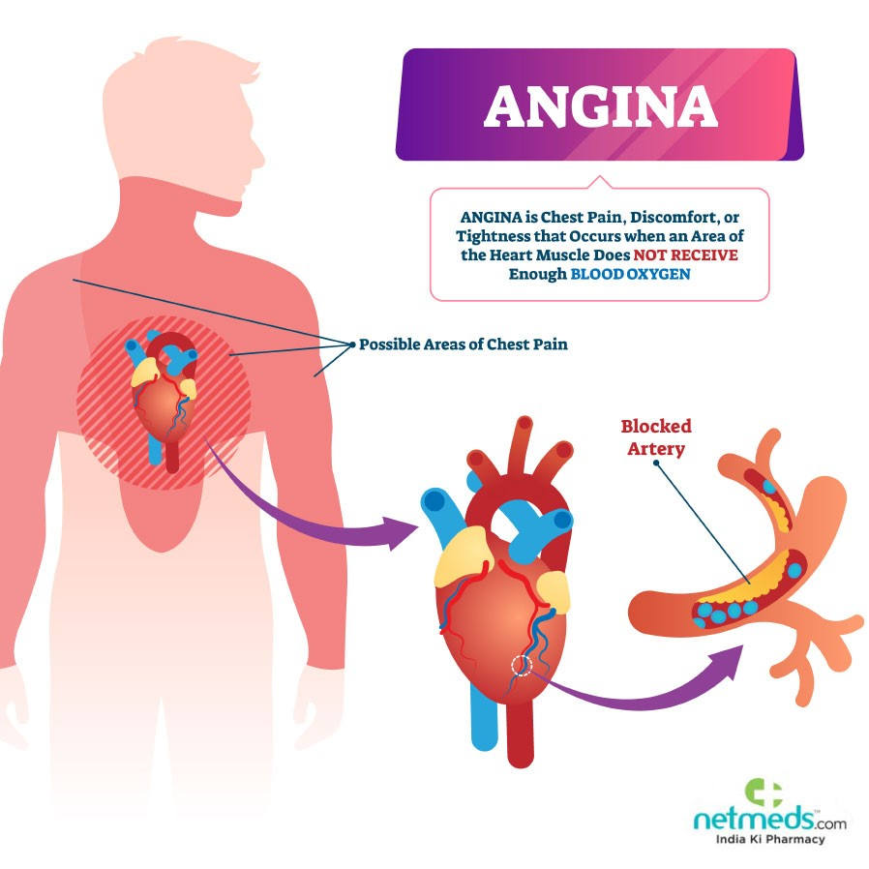

What Causes a Heart Attack?

Heart attacks are not caused by narrowed arteries. They are caused by a sudden breaking off of a plaque from the inner lining of an artery leading to the heart. After the plaque breaks off, the area bleeds and clots. Then the clot extends to block the flow of blood to the heart muscle. If the blood flow is completely blocked the heart muscle will die.

If You Have Chest Pain

If your doctor thinks that you have unstable angina (chest pain when you are not exercising), a heart attack or heart pain other than stable angina, he may hospitalize you. If he thinks that you have stable angina, he may order the following tests:

* EKG (Electrocardiogram that measures the electrical activity of your heart)
* Stress Test (an EKG in which you exercise to make your heart work hard and beat fast)
* Chest X Ray (pictures of your heart, lungs, and blood vessels) • Coronary Angiography (injecting dyes into your bloodstream to see if the arteries leading to your heart are narrowed or blocked) • Cardiac Catheterization (a thin, flexible catheter is put into a blood vessel in your arm, groin, or neck and is threaded into your coronary arteries)
* Blood Tests (cholesterol, triglycerides, sugar, CRP, proteins in your blood and so forth)